**  
Assistive Reality ARX presale participation  
ARX Token: 0xb0D926c1BC3d78064F3e1075D5bD9A24F35Ae6C5  
Presale Contract: 0x4Ee1d7720a04072142B2efC9d2C7d5d77Ad63939  
Presale Contract details/JSON if wanted:** [**View on Etherscan**](https://etherscan.io/address/0x4ee1d7720a04072142b2efc9d2c7d5d77ad63939)**,** [**View GitHub**](https://github.com/assistivereality/ico/blob/master/masterARXtoken6presale.sol)

**Limited** Pre-sale cap: **1,000 ETH  
PRICING**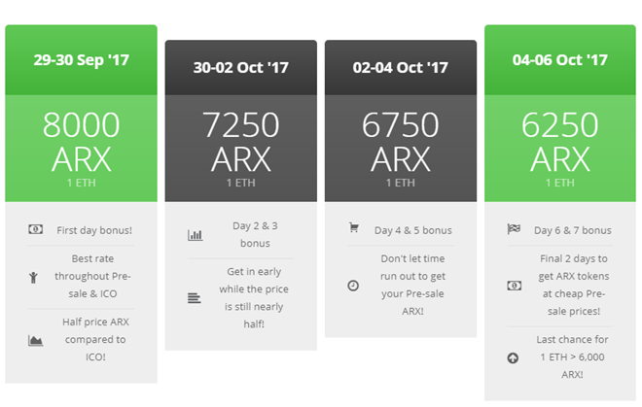

**Start block: #4,323,376   
Start:** 30 Sep 1AM - **End:** 07 Oct 1AM GMT  
30 Sep 1AM GMT: 1 ETH = **8,000 ARX**  
01 Oct 1AM GMT: 1 ETH = **7,250 ARX**  
03 Oct 1AM GMT: 1 ETH = **6,750 ARX**  
05 Oct 1AM GMT: 1 ETH = **6,250 ARX**

**Note: prior to purchasing ARX, please ensure the legal disclaimer on page 8 is reviewed. Proceeding to purchase ARX tokens indicate you understand and accept the legal disclaimer. A Chinese translation of the disclaimer is available upon request.**

**Contents**

**Mist** instructions – buy some ARX tokens 2

**Parity** instructions – buy some ARX tokens 3

**Pre-sale and ICO Legal disclaimer** 8

# **Mist** instructions – buy some ARX tokens

**NOTE:** Mist can take a very long time to synchronise. If you have issues, use Parity or IM.Token.  
This guide also assumes you have also followed part 1 (to ‘watch’ the ARX token address)

1. Open Mist
2. Ensure you have followed Part 1 document “1. ARXToken-WatchInstructions.docx” to be watching the ARX Token address
3. Click the Send Button:

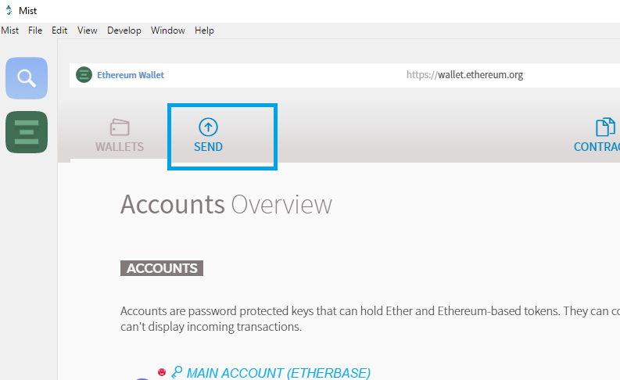

1. Paste the Presale contract address into the To field

**0x4Ee1d7720a04072142B2efC9d2C7d5d77Ad63939**

1. Input your desired amount of ETH to exchange for ARX. It is expected to use **98,000 gas** minimum depending on whether you purchased previously. Both Mist and Parity work OK by default (and IM.Token) however if you have any issue, try increasing the provided gas amount with the transaction. If you use the ‘Watch Contract’ and ABI method to execute ‘BuyTokens’ function, you should provide **125,000 gas** minimum.
2. Once configured like this, submit the transaction with your password:

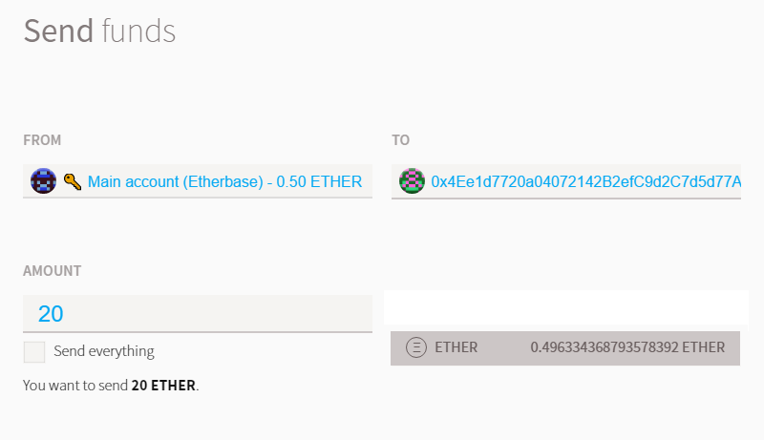

1. You will then receive your tokens straight away in a return transaction (normal transaction times apply). Ensure you backup your wallet and store important / valuable tokens or keys in a safe location.

# **Parity** instructions – buy some ARX tokens

1. Open Parity client on desktop, and ensure you have reached 100% warp restore before you actually transfer any tokens:

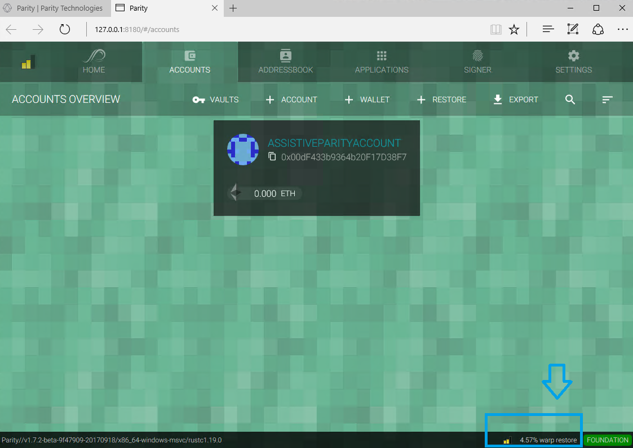

1. Click Accounts, then select your account with ETH in it

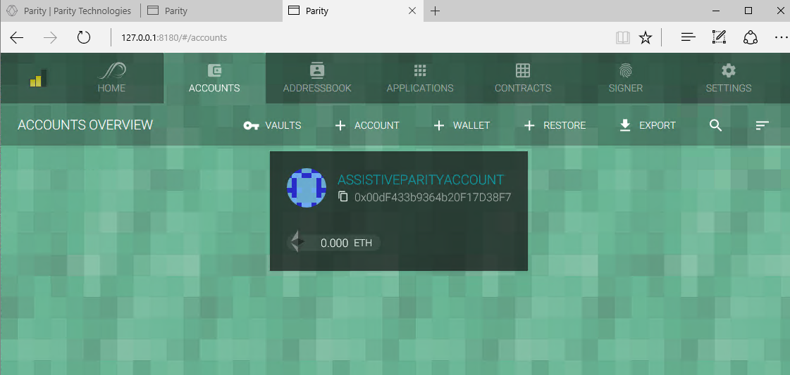

1. Click Accounts, then select your account with ETH in it, then click the Send Icon:

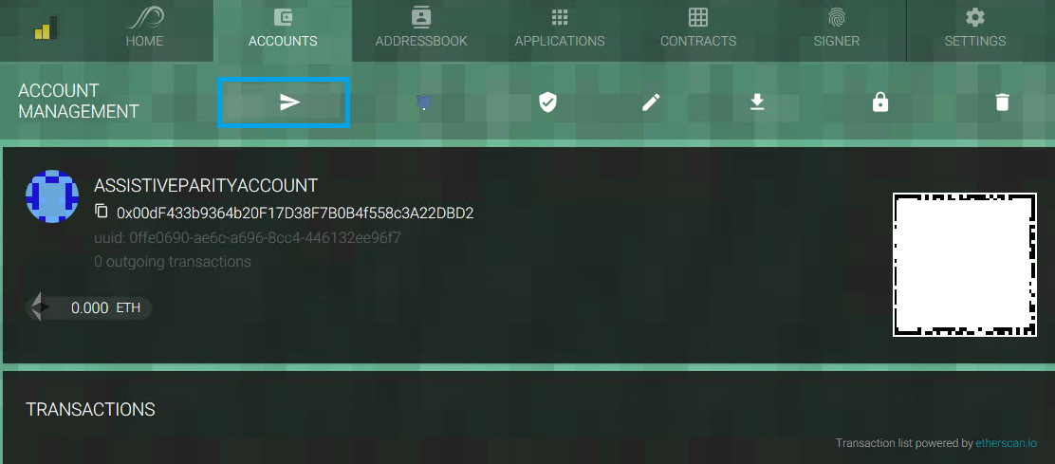

1. Enter the address of the Pre-sale contract, choose advanced options, then choose next

**0x4Ee1d7720a04072142B2efC9d2C7d5d77Ad63939**

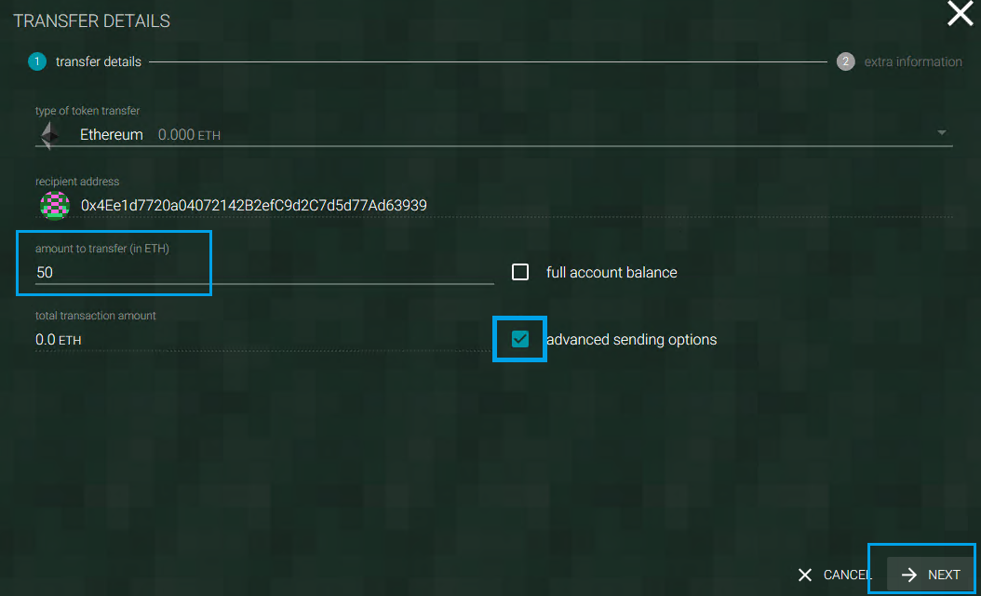

(It’s suggested to use a slightly higher gas value but should not be required with the newer versions of Mist or Parity. Use **98,000 Gas.** If any issue occurs set it up to **125,000 Gas.**

1. You will receive your ARX tokens immediately in return from the smart contract. Normal transaction processing times apply.

Assistive Reality ARX **Pre-sale** information  
Presale contract addr: **0x4Ee1d7720a04072142B2efC9d2C7d5d77Ad63939**

**Etherscan** link for Pre-sale contract:  
<https://etherscan.io/address/0x4Ee1d7720a04072142B2efC9d2C7d5d77Ad63939>

**Github** source code for token contract (fully regression tested and security audited)  
<https://github.com/assistivereality/ico/raw/master/masterARXtoken6presale.sol>

**Type of Supply:** Fixed, static, no more can be created  
  
**Supply total:** 318,000,000 (includes 16M private sale packages, 8M presale, 250M ICO, 12M frozen employee bonus tokens, and 32M foundation fund allocation)

Assistive Reality ARX token information  
Token address: **0xb0D926c1BC3d78064F3e1075D5bD9A24F35Ae6C5**

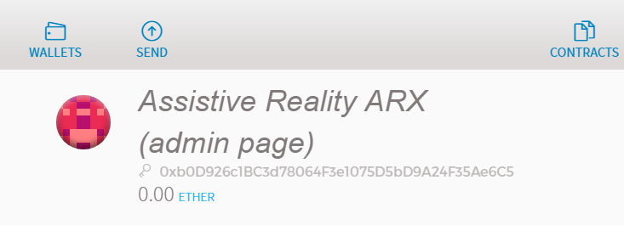

**Etherscan** link for token contract  
<https://etherscan.io/address/0xb0d926c1bc3d78064f3e1075d5bd9a24f35ae6c5>

**Github** source code for token contract (fully regression tested and security audited)  
<https://github.com/assistivereality/ico/blob/master/masterARXtoken6.sol>

**Type of Supply:** Fixed, static, no more can be created  
  
  
**Supply total:** 318,000,000 (includes 16M private sale packages, 8M presale, 250M ICO, 12M frozen employee bonus tokens, and 32M foundation fund allocation)

## **Pre-sale and ICO Legal disclaimer**

By participating in the Assistive Reality ARX Pre-sale and/or ICO Token Crowdsale or making use of any information in this whitepaper or available on the aronline.io website, you agree to the following:

**GENERAL WARNING-**By using the services provided by Assistive Reality, you the (User) as either an Initial Coin Offering (hereinafter – Pre-sale and/or ICO or Crowdsale) participant or (User) of Assistive Reality alpha products or services, fully understands and agrees with the following:

* User understands and acknowledges that ARX tokens will be provided by the Pre-sale and/or ICO smart contract in the order that transactions are received by it and no alteration of this can be made by any party
* User understands that Assistive Reality carries no liability for the ability to take part in the Pre-sale and/or ICO for reasons beyond the control of Assistive Reality including but not limited to the Pre-sale and/or ICO duration, transaction mining delays and node-related issues
* Pending a successful Pre-sale and/or ICO, Assistive Reality team members will be focused on completing the company start-up and delivering on milestones. However Assistive Reality undertakes no obligations to act on behalf and in the interests of User in the Pre-sale and/or ICO being held in the future
* User understands that by transferring assets to Assistive Reality, User makes the final decision on deposition of cash or other assets and has no right of refund except that which is provided by the Pre-sale and/or ICO smart contract code itself (that being, a 100% refund when capital raised is under the minimum cap and the Pre-sale and/or ICO/crowdsale period has expired)

**TAX WARNING-**  
User understands that Assistive Reality does not act as a tax agent of User; User and Assistive Reality carry their tax obligations solely under the applicable laws of the country and location they reside in. Assistive Reality is not a tax agent and therefore shall not provide Users' financial information to any third parties. This information shall not be disclosed unless officially requested by government authorities.

**NO WARRANTIES-**All of the information provided within this whitepaper is provided “AS-IS” and with no warranties. No express or implied warranties of any type, including implied warranties of merchantability or fitness for a particular purpose, are made with respect to the information, or any use of the information, on this site or platform. Assistive Reality makes no representations and extends no warranties of any type as to the accuracy or completeness of any information or content in this whitepaper or regarding this platform.

**DISCLAIMER OF LIABILITY-**Assistive Reality specifically disclaims liability for incidental or consequential damages and assumes no responsibility or liability for any loss or damage suffered by any person as a result of the use or misuse of any of the information or content in this whitepaper or on the aronline.io website. Assistive Reality assumes or undertakes no liability for any loss or damage suffered as a result of the use, misuse or reliance on the information and content in this whitepaper or on the aronline.io website.

In no event shall Assistive Reality be liable to User for any special, indirect, incidental, consequential, exemplary or punitive damages (including lost or anticipated revenues or profits and failure to realise expected savings arising from any claim relating to the services provided by Assistive Reality) whether such claim is based on warranty, contract, tort (including negligence or strict liability) or otherwise or likelihood of the same.

**USE AT YOUR OWN RISK-**By using the Pre-sale and/or ICO smart contract for ARX, the Assistive Reality platform or aronline.io website including but not limited to the transferring assets to Assistive Reality, User confirms that he undertakes and understand all the possible risks that directly or indirectly arise from the activity connected with User’s participation in the Pre-sale and/or ICO and/or use of Assistive Reality services and products.

**FORCE-MAJEURE-**User understands that Assistive Reality will not be liable to User for any breach hereunder, including for failure to deliver or delays in delivery of the Services occasioned by causes beyond the control of Assistive Reality including but not limited to unavailability of materials, strikes, labour slowdowns and stoppages, labour shortages, lockouts, fires, floods, earthquakes, storms, droughts, adverse weather, riots, thefts, accidents, embargoes, war (whether or not declared) or other outbreak of hostilities, civil strife, acts of governments, acts of God, governmental acts or regulations, orders or injunctions, or other reasons, whether similar or dissimilar to the foregoing (each a “Force Majeure Event”).

**NOT A SECURITY, ALTERNATIVE-TO-CASH OR OTHER VALUE HOLDER-**User understands that Assistive Reality ARX tokens are not offered as a security, share, alternative-to-cash or any other form of tangible value holder. Tokens are to be used and consumed on an entirely individual basis separate from the operation of cash assets or other transfers to/from fiat currency cash holders. There is no relationship between ARX tokens and monetary value other than that conferred by third-party digital currency exchanges unrelated to Assistive Reality. At no point in time does Assistive Reality confer, imply or grant any value to ARX tokens other than ARX tokens can be used to unlock unique items within an Assistive Reality experience, application, or platform tool.

**FINAL WARNING-**Pre-sale and/or ICO participations can be can be considered High-Risk Trading; purchasing financial instruments via a Pre-sale and/or ICO or utilising services offered on the website may result in significant losses or even in a total loss of all funds invested.

* No information provided on Assistive Reality’s platform or website should be interpreted as investment advice. It does not constitute an offer or invitation by Assistive Reality to any User to buy or to sell tokens or make any investment.
* User guarantees that he is a legally capable person of a majority age and complies with legal rules and applicable laws of the jurisdiction where the User lives.
* User guarantees the purchase of ARX tokens does not contravene legislation in their country and/or geographical area pertaining to the purchase, storage, and exchange of digital currency assets including tokens.
* By participating in the Pre-sale and/or ICO User confirms that he has read, understood and agree to comply with all restrictions set forth above.